

Advanced Technological Institute

Galle

**FINAL REPORT**

**Group 09**

**NETWORK SYSTEM**

**FOR**

**Ihala Beligalla Maha Vidyalaya**

**Beliatta**

Higher National Diploma in Information Technology

2nd Year – 1st Semester

HNDIT2304 – Project (Group)

**Network System For** **Ihala Beligalla Maha Vidyalaya - Beliatta**

By

M.L.N.J. Rahul Kumara GAL/IT/2020/F/0053

S. Dimuthu Lanka GAL/IT/2020/F/0062

K. Lasith Lahiru Madushan GAL/IT/2020/F/0064

E.P. Ishan Charuka Bandara GAL/IT/2020/F/0071

K.K.G. Ishani Chathumini GAL/IT/2020/F/0090

Group

THE REPORT

Submitted in partial fulfilment of the requirement

Of

**HIGHER NATIONAL DIPLOMA IN INFORMATION TECHNOLOGY**

2022

LABUDUWA ADVANCED TECHNOLOGICAL INSTITUTE

GALLE

-APPROVED-

…………………………………… …………………………………….

|  |  |
| --- | --- |
| Mr.S. Ramanayake, | Mr.K.M.G.T.R. Waidyarathne, |
| THE SUPERVISOR, | THE HEAD, |
| THE DIRECTOR, | DEPARTMENT OF IT, |
| ADVANCED TECHNOLOGICAL | ADVANCED TECHNOLOGICAL |
| INSTITUTE, | INSTITUTE, |
| LABUDUWA. | LABUDUWA. |
| Date: …………………….. | Date: ……………………… |

……………………………………………………

Mr.S. Ramanayake,

THE DIRECTOR,

ADVANCED TECHNOLOGICAL INSTITUTE,

LABUDUWA.

Date: ……………………….

Supervisor: Mr.S. Ramanayake

**SRI LANKA INSTITUTE OF ADVANCED TECHNOLOGICAL EDUCATION**

**LABUDUWA ADVANCED TECHNOLOGICAL INSTITUTE DEPARTMENT OF INFORMATION TECHNOLOGY**

**IT SPECIALIZATION PROJECT REPORT HEADER SHEET**

**(To be completed and signed by the students)**

Student Registration Number: ……………………………………

Family Name and Initial: …………………………………………...

Project Title: ………………………………………………………….

**PLAGIARISM**

You are reminded that there exist regulations concerning plagiarism. Extracts from these regulations are printed overleaf. Please sign below to say that you have read and understand these extracts:

………………………………………… ………………………………………..

Signature Date

**For supervisor to complete**

Data received: ………………………………………………..

Name of the supervisor: ……………………………………

Signature: ……………………………………………………..

Date: ……………………………………………………………

**ABSTRACT**

We have chosen Ihala Beligalla Maha Vidyalaya located at – in Beliatta. This School has total of 18 desktop computers and a printer in the computer lab. 16 computers are allocated for the students and 2 computers allocated for the staff among the above computers. Two additional computers, a printer, and a photocopy machine are available in the office. the computers of this school are not networked, they both don’t have the resources needed to keep pace and updated with technology, Internet-based learning materials, and communication between staff and students.

We made the decision to upgrade the resources offered by the school and link a centralized computer network.

**ACKNOWLEDGEMENT**

It’s a great pleasure to us take this opportunity to deliver our worthy thanks those who be a guardian, and supporters to succeed our task. So, We please to deliver our sincere gratitude to Mr.S. Ramanayake for guiding us all the way through the project. Its honor to us sincerely mention the HOD sir Mr.K.M.G.T.R. Waidyarathne, for leading us in new areas in the industry.

It is our bond to be thanking to Principal of Ihala Beligalla Maha Vidyalaya which gives permission to be conduct the project.

We please to deliver our sincere gratitude to academic and non-academic staff members for help us to success this project.

Contents

**Chapter 01** 8

Introduction 8

Existing System 9

Problem and Weakness of the current system 9

1.3 Aims 10

1.4 Benefits To The School 10

1.5 Objective 10

1.6 Building Plan for Proposed System 11

1.7 Network Plan for Proposed System 12

1.8 Requirements 13

1.9 Technical Requirements 13

1.10 Project Schedule 14

**Chapter 2** 15

Design 15

2.1 Network Topologies 15

2.2 Hybrid Topology 16

2.2.1 Advantages 16

2.2.2 Disadvantages 17

2.3 Types of Networks 18

2.3.1 Local Area Network (LAN) 19

2.4 Wireless Media 19

2.5 Network Architectures 19

2.5.1 Peer-to-peer 20

2.5.2 Client / Server 21

2.5.3 Advantages of client server architecture 21

2.5.4 Disadvantages of client server architecture 21

2.6 Technical Specification 22

2.7 Physical Topology 35

2.7.1 Switch 36

2.7.2 Router 36

2.7.3 Network Cable 37

2.8 Logical Topology 38

2.8.1 Ip Address 38

2.8.2 DHCP 39

2.8.3 Routing Protocol 39

2.9 Quotation of the Network 40

2.10 System Requirement 41

2.11 Operational Requirement 41

2.12 Software Requirement 41

2.13 Tools Required for the Network 42

**CHAPTER 03** 43

PACKET TRACER DESIGN 43

3.1 Packet Tracer Designing Diagram 43

3.2 Network Addresses & IP Addresses 44

3.2.1 Switch 0 PC’s IP Address 44

3.2.2 Switch 1 PC’s IP Addresses 44

3.3.3 Hub to Office PC’s IP Address 45

Router 0 Configuration 45

Router 0 SHOW IP INTERFACE BRIEF 46

Router 1 Configuration 47

Router 1 SHOW IP INTERFACE BRIEF 48

Router 2 Configuration 49

Router 2 SHOW IP INTERFACE BRIEF 50

Printer working 51

REFERENCES 53

# **Chapter 01**

## Introduction

The school doesn't have a network system, they both don’t have the resources needed to keep pace and updated with technology, Internet-based learning materials, and communication between staff and students. This prosses will take lot of time and the effected. Because of that we decided to make them a real reliable computer network system and we made clear simple solutions to the students, staff members and whole school for a secure network system.

## Existing System

Schools can operate without a network system, but it would be difficult to achieve the same level of efficiency and effectiveness as schools with network systems. Here are some of the challenges that schools may face without a network system:

* Limited communication: Without a network system, communication among students, teachers, and staff would be limited to in-person meetings, phone calls, and emails. This could make it difficult to coordinate schedules, share resources, and collaborate on projects.
* Limited access to online resources: Many educational resources are now available online, including textbooks, multimedia content, and educational software. Without a network system, it would be difficult for schools to provide students with access to these resources.
* Limited security: Without a network system, it would be difficult for schools to implement appropriate security measures to protect sensitive data. This could put the school at risk of data breaches and other security incidents.

In conclusion, while it is possible for schools to operate without a network system, doing so would limit their ability to communicate, collaborate, and access online resources. It could also make administrative processes more time-consuming and error-prone and put the school at risk of security incidents. Therefore, it is recommended that schools have a network system in place to support their operations.

## Problem and Weakness of the current system

* + - Resources cannot be shared with staff members and students.
    - Official information is not secure.
    - Time consumes.
    - Human mistakes may occur.
    - Document sharing is pricey and extremely sluggish.
    - Limited access to distance learning

## 1.3 Aims

* The network system enables students, teachers, and staff to communicate with each other easily and quickly.
* The network system can provide access to online resources, multimedia content, and educational software. The aim is to improve the quality of education, enhance student engagement, and enable personalized learning experiences.
* The network system can help schools streamline administrative tasks, such as record-keeping, student information management, and financial management. The aim is to reduce the time and resources spent on administrative tasks and enable schools to focus on delivering quality education.
* The network system can help schools protect sensitive data and prevent unauthorized access. The aim is to ensure that the school's network is secure and that data is kept confidential.

## 1.4 Benefits To The School

## 

* Enhancing the effectiveness of administrative tasks.
* Improved data management.
* Connecting the entire network to one internet.
* Transmission of data and information is standardized.
* Limit use of the internet and avoid unscrupulous websites.

## 1.5 Objective

the objectives of a network system for a school are to improve communication, enhance learning outcomes, streamline administrative processes, improve data management, provide access to distance learning, enhance security, increase efficiency and productivity, and improve collaboration. By achieving these objectives, schools can provide the best possible education for their students and improve overall school operations.

## 1.6 Building Plan for Proposed System

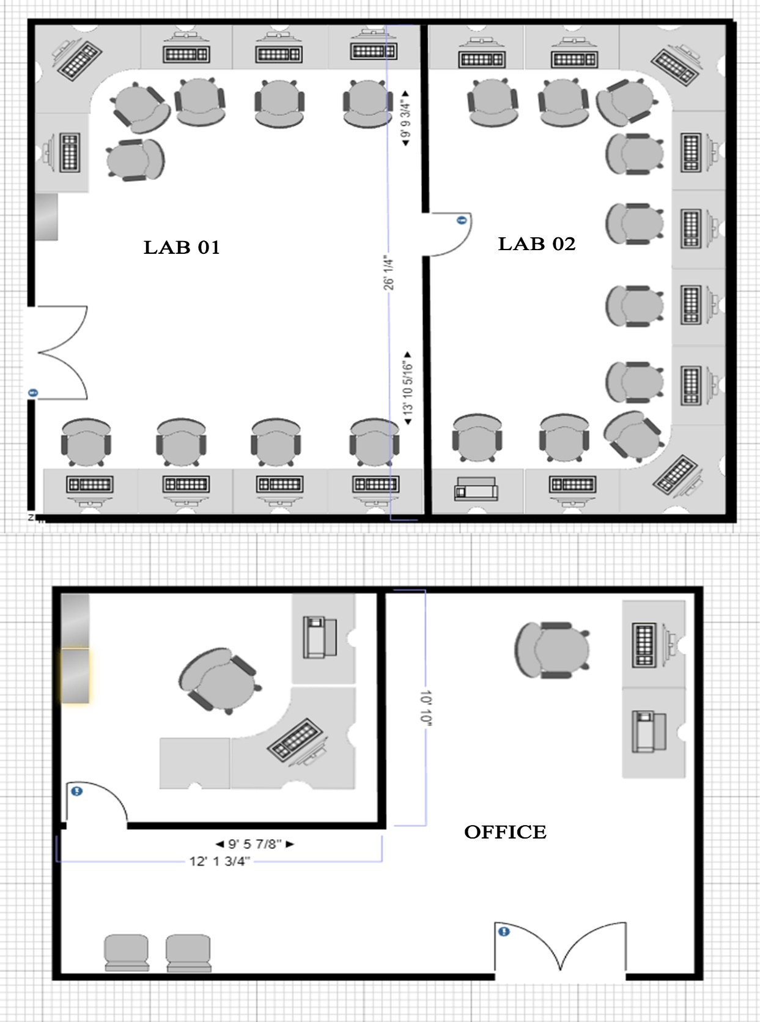

## 1.7 Network Plan for Proposed System

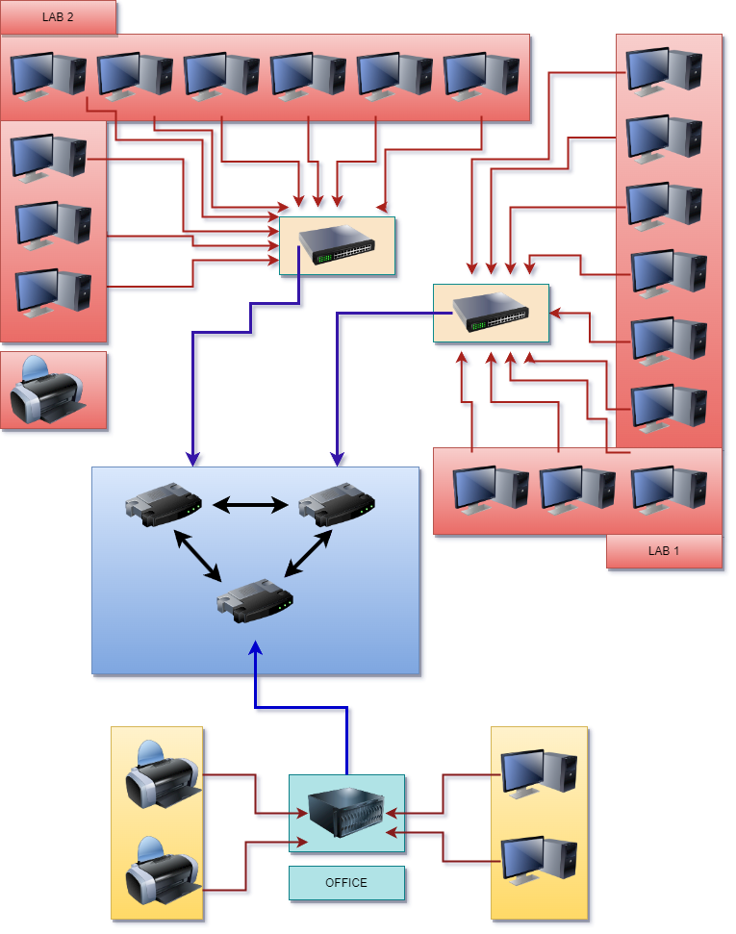

## 1.8 Requirements

## 1.9 Technical Requirements

|  |  |  |
| --- | --- | --- |
| **Object** | **Specification** | **Quantity** |
| Switch | Cisco 2950 - 24 | 2 |
| Router | Cisco 1841 | 3 |
| Hub | Cisco Hub-PT | 1 |
| Connectors | RJ45 | 60 |
| Network Casing | Polycrome | 1000FT |
| Wall plug/anchor | Size 10 |  |
| Printers | PIXMA G2020 | 3 |
| Flexible Wire |  | 2500FT |
| Quad shield Wire | 3in1 copper cctv wire | 2000FT |
| PC | I5 – 4507 3.2GHz | 20 |

## 1.10 Project Schedule

Time framework uses to determine the start and end date of the project and its activities.

|  |  |  |  |  |  |  |  |  |  |  |  |  |
| --- | --- | --- | --- | --- | --- | --- | --- | --- | --- | --- | --- | --- |
| **Task** |  |  |  |  |  | **Week** | |  |  |  |  |  |
| **1** | **2** | **3** | **4** | **5** | **6** | **7** | **8** | **9** | **10** | **11** | **12** |
| Information Gathering |  |  |  |  |  |  |  |  |  |  |  |  |
| Proposal Submission |  |  |  |  |  |  |  |  |  |  |  |  |
| Requirement Gathering |  |  |  |  |  |  |  |  |  |  |  |  |
| Requirement Analyze |  |  |  |  |  |  |  |  |  |  |  |  |
|  |
| Network Designing |  |  |  |  |  |  |  |  |  |  |  |  |
|  |  |
| Testing |  |  |  |  |  |  |  |  |  |  |  |  |
|  |
| Document |  |  |  |  |  |  |  |  |  |  |  |  |
| Implementation |  |  |  |  |  |  |  |  |  |  |  |  |
|  |

# **Chapter 2**

## Design

## 2.1 Network Topologies

Network topology is a topological structure of computer network. Which can be physical or logical. The physical topology depicts location different computer elements such as computer cables and other devices. The logical topology visually displays network data flows from the same devices to another. Sometimes network logical and physical topologies can be the same or the physical topology of a network refers to the configuration of cables, computers, and other peripherals. Physical topology should not be confused with logical topology which is the method used to pass information between workstations.

Network topologies are categorized into the following basic types;

1. Star Topology
2. Ring Topology
3. Bus Topology
4. Tree Topology
5. Mesh Topology
6. Hybrid Topology

In here we are using Hybrid topology.

## 2.2 Hybrid Topology

A hybrid topology is a type of network topology that combines two or more different types of topologies to form a single network. It typically involves the use of multiple interconnected sub-networks, each with its own topology, that are connected to a central network device, such as a switch or router.

For example, a hybrid topology might combine a star topology with a bus topology, where several star networks are connected via a common backbone bus network. This type of topology offers the advantages of both star and bus topologies, such as centralized management and easy scalability of the star network, as well as the flexibility and redundancy of the bus network.

Another example of a hybrid topology is a ring-star topology, which combines the ring topology and the star topology. In this type of topology, multiple ring networks are connected to a central hub, forming a star-like structure. This allows for redundancy and fault tolerance, as well as easy expansion of the network by adding new ring networks.

Hybrid topologies can be complex and require careful planning and management, but they can also offer the benefits of multiple topologies and provide a more flexible and robust network infrastructure.

## 2.2.1 Advantages

* Scalability: Hybrid topology allows for easy scalability as new devices and networks can be added without having to replace or reconfigure the entire network.
* Flexibility: Hybrid topology is flexible and can be customized to meet the specific needs of a network. Different sub-networks can be added, removed or modified according to the changing requirements of the network.
* Fault tolerance: Hybrid topology provides redundancy and fault tolerance, which means that if one part of the network fails, the other parts can continue to function without interruption.
* Centralized management: The central network device in a hybrid topology, such as a switch or router, makes it easy to manage and control the entire network from a single location.
* Improved performance: By combining different types of topologies, hybrid topology can provide improved performance, reliability, and efficiency compared to a single topology network.
* Security: Hybrid topology can improve network security by allowing for the segregation of different types of traffic and the use of different security measures in each sub-network.

Overall, the advantages of hybrid topology make it a popular choice for many types of networks, especially those that require flexibility, scalability, and fault tolerance.

.

## 2.2.2 Disadvantages

* Complexity: Hybrid topology can be complex and difficult to manage, especially as the network grows and new sub-networks are added. This can result in higher maintenance costs and more time-consuming management tasks.
* Cost: Implementing a hybrid topology can be more expensive than other types of topologies due to the need for multiple devices and network components, such as switches, routers, and cables.
* Technical expertise: Hybrid topology requires technical expertise to design, implement, and manage, which may not be readily available to some organizations. This can result in higher training costs or the need to hire specialized IT staff.
* Potential for bottlenecks: Hybrid topology can be susceptible to bottlenecks, particularly at the central network device where multiple sub-networks converge. This can impact network performance and reliability.
* Security vulnerabilities: Because hybrid topology involves multiple sub-networks, each with its own security measures, there is the potential for security vulnerabilities if one sub-network is compromised.

Overall, while hybrid topology has many advantages, it is important to consider the potential drawbacks when deciding whether it is the right choice for a particular network. Proper planning, design, and management can help mitigate many of these issues and ensure a successful implementation.

## 2.3 Types of Networks

There are several different types of computer networks. Computer networks can be characterized by their size as well as their purpose. The size of a network can be expressed by the geographic area they occupy and the number of computers that are part of the network. Networks can cover anything from a handful of devices within a single room to millions of devices spread across the entire globe.

Some of the different networks based on size are

* LAN
* WAN
* CAN
* PAN
* MAN

## 2.3.1 Local Area Network (LAN)

A local area network (LAN) is a computer network that interconnects computers within a limited area such as a residence, school, laboratory, university campus or office building. By contrast, a wide area network (WAN) not only covers a larger geographic distance, but also generally involves leased telecommunication circuits.

## 2.4 Wireless Media

Many LANs use wireless technologies that are built into Smartphones, tablet computers and laptops. In a wireless local area network, users may move unrestricted in the coverage area. Wireless networks have become popular in residences and small businesses, because of their ease of installation. Guests are often offered Internet access via a hotspot service

## 2.5 Network Architectures

There are several ways in which a computer network can be designed. Network architecture refers to how computers are organized in a system and how tasks are allocated between these computers. Two of the most widely used types of network architecture are;

* peer-to-peer
* client/server

## 2.5.1 Peer-to-peer

In a peer-to-peer or P2P network, the tasks are allocated among all the members of the network. There is no real hierarchy among the computers, and all of them are considered equal. This is also referred to as a distributed architecture or workgroup without hierarchy. A peer-to-peer network does not use a central computer server that controls network activity. Instead, every computer on the network has a special software running that allows for communications between all the computers.

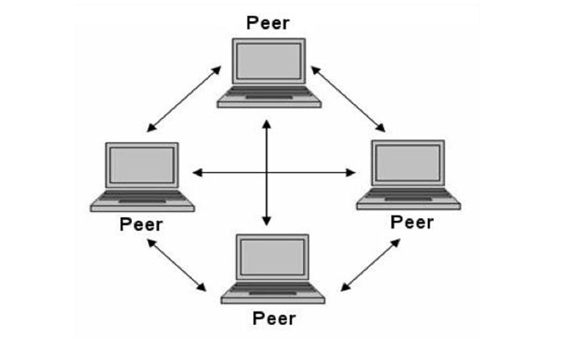

## 2.5.2 Client / Server

In a client/server network, a number of network clients or workstations request resources or services from the network. One or more network servers manage and provide these resources or services. The clients are computers that depend on the server for data and software. Network servers are also referred to as computer servers, or simply servers. Sometimes a server is described in terms of the specific service it provides, such as email server, print server or storage server. Some servers, however, can provide all these services.

## 2.5.3 Advantages of client server architecture

* Security is better – Centralized, one person is given responsibility for it.
* Centralized data – data is held on a file server which means that all users have access to the same set of data.
* Backups are taken centrally – regular and people don’t have to be responsible for taking backups.
* Faster access to programs and files – servers are used which are powerful computer.
* Centralized administrations – all the administration of the network is performed centrally so user do not have to worry about it.

## 2.5.4 Disadvantages of client server architecture

* More expensive – servers are expensive.
* Need specialist knowledge – need to have a person who has good ICT knowledge to maintain the network.
* Software is sophisticated and expensive.
* If the server breaks the network is un usable.

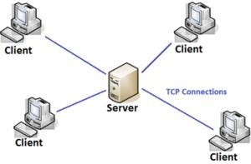

## 2.6 Technical Specification

**Router**

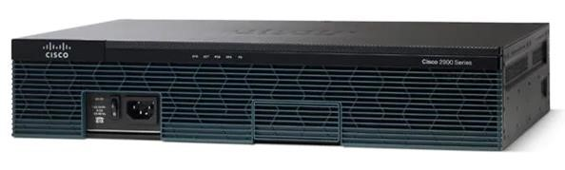

|  |  |
| --- | --- |
| **Specifications** | |
| Brand | CICSO |
| Model | [Cisco](https://www.cisco.com/c/en/us/support/routers/2900-series-integrated-services-routers-isr/series.html) 1841 [Series Integrated Services Routers](https://www.cisco.com/c/en/us/support/routers/2900-series-integrated-services-routers-isr/series.html) |
| Integrated WAN Ports | 3 GE |
| Non-Operating Altitude | 15,000 ft (4,570m) |
| External USB 2.0 Flash Memory Slots (Type A) | 2 |
| Wall-Mount (refer to installation guide for approved orientation) | Yes |
| Temperature: 9,843 feet (3,000m ) Maximum Altitude | 32 to 77 F (0 to 25 C) |
| Typical Power (No Modules) (Watts) | 50 |
| Cisco Unified SRST Sessions | 50 |
| Power Supply | AC; PoE; and DC |
| USB Console port (Type B) (up to 115.2 kbps) 1 | 1 |
| Compact Flash (External) - Default | slot 0: 256 MB; slot 1: none |
| Optional Airflow Kit | Front to back |
| Maximum End-Point PoE Power Capacity with PoE Boost (Watts) | 750 |
| Double-Wide EHWIC Slots | 2 |
| Non-Operating Temperature | -40 to 176 F (-40 to 80 C) |
| Serial console port | 1 |
| RJ-45-based ports | 3 |
| Weight | 21 lb (9.5 kg) fully configured (typical) |

|  |  |
| --- | --- |
| Maximum End-Point PoE Power  Available from DC PoE Power Supply (Watts) | 160 |
| Memory DDR2 ECC DRAM - Default | 512 MB |
| ISM Slots | 1 |
| Maximum Power with AC Power  Supply (Watts) | 210 |
| Compact Flash (External) - Maximum | slot 0: 4 GB; slot 1: 4 GB |
| Airflow | Side to side |
| DC Input Current | (MAX) 8A (24V); 3.5A (60V) |
| Dimensions (H x W x D) | 3.5 x 17.25 x 12 in. (88.9 x 438.2 x  304.8 mm) |
| Non-Operating Relative Humidity | 5 to 95% |
| Relative Humidity | 5 to 85% |
| Weight with AC Power Supply (No Modules) | 18 lb (8.2 kg) |
| EHWIC Slots | 4 |
| Onboard DSP (PVDM) Slots | 2 |
| Temperature: 5,906 feet (1,800m) Maximum Altitude | 32 to 104 F (0 to 40 C) |
| SFP-Based Ports | 3 |
| Acoustic: Sound Power (Typical/Maximum) | 58.5/70.3 dBA |
| Cisco Unified CCME Sessions | 50 |
| Weight with AC PoE Power Supply (No Modules) | 19 lb (8.6 kg) |
| Memory DDR2 ECC DRAM - Maximum | 2 GB |
| AC Input Voltage | 100 to 240 VAC auto ranging |
| Rack Units | 2 RU |
| Total onboard WAN 10-100-1000  Ports | 3 |
| Embedded Hardware-Based  Cryptography and Acceleration | Yes |
| Typical Weight Fully Configured | 21 lb (9.5 kg) |
| Maximum Power with DC-PoE Power  Supply (Platform Only) (Watts) | 140 |
| Short-Term (per NEBS) Humidity | 5% to 90%, but not to exceed 0.024 kg water/kg of dry air |
| Temperature: 13,123 feet (4,000m) Maximum Altitude | 32 to 86 F (0 to 30 C) |
| Modular LAN Switchports (with optional PoE) | 24 |
| AC Input Surge Current | < 50A |
| Rack-Mount 19 in. (48.3 cm) EIA | Optional |
| AC Input Current | 2.2 to 1.0A range (max AC power supply) |
| Temperature: Short-Term (per NEBS) 5906 feet (1,800m) Maximum Altitude | 23 F to 122 F (-5 to 50 C) |
| RPS Support (External) | Cisco RPS 2300 |
| Maximum End-Point PoE Power  Available from AC PoE Power Supply (Watts) | 200 |
| AC Input Frequency | 47 to 63 Hz |
| Rack Mounting Kit | Included |
| Maximum Power with PoE Power Supply (Platform Only) (Watts) | 250 |
| Acoustic: Sound Pressure (Typical/Maximum) | 51.8/62.9 dBA |

**Switches (LAN)**

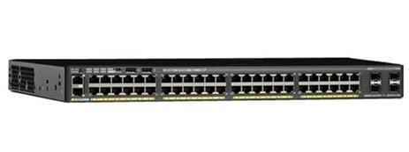

|  |  |
| --- | --- |
| **GENERAL** | |
| Manufacturer | CISCO |
| Model | 2950 - 24 |
| **HARDWARE SPECIFICATIONS** | |
| Flash Memory | 128 MB for LAN Base & IP Lite SKUs, 64  MB for LAN  Lite SKUs |
| Dram | 512 MB |
| Cpu | APM86392 600MHz dual core |
| Console Ports | USB (Type-B), Ethernet (RJ-45) |
| Storage Interface | USB (Type-A) for external flash storage |
| Network Management Interface | 10/100 Mbps Ethernet (RJ-45) |
| **PERFORMANCE AND SCALABILITY** | |
| Forwarding Bandwidth | 50 Gbps |
| Switching Bandwidth* | 100 Gbps |
| Maximum Active Vlans | 64 |
| Vlan Ids Available | 4096 |
| Maximum Transmission Unit (Mtu) -  L3  Packet | 9198 bytes |
| Jumbo Frame - Ethernet Frame | 9216 bytes |
| **FORWARDING RATE: 64-BYTE L3**  **PACKETS** | |

|  |  |  |
| --- | --- | --- |
| Cisco Catalyst 2960x-48fpd-L | 130.9 Mpps |  |
| **MECHANICAL SPECIFICATIONS** | |  |
| Dimension | 1.75 x 14.5 x 17.5 (HxDxW in  Inch) | 4.5 x 36.8 x 44.5  (HxDxW in  CM) |
| Weights | 12.9 lbs | 5.8 Kg |
| **ENVIRONMENTAL RANGES** | |  |
|  | **Fahrenheit** | **Centigrade** |
| Operating Temperature Up To 5000  Ft  (1500 M) | 23ºF to 113ºF | -5ºC to  45ºC |
| Operating Temperature Up To  10,000 Ft  (3000 M) | 23ºF to 104ºF | -5ºC to  40ºC |
| Short-Term Exception At Sea Level* | 23ºF to 131ºF | -5ºC to  55ºC |
| Short-Term Exception Up To 5000  Feet  (1500 M)* | 23ºF to 122ºF | -5ºC to  50ºC |
| Short-Term Exception Up To 10,000  Feet  (3000 M)* | 23ºF to 113ºF | -5ºC to  45ºC |
| Short-Term Exception Up To 13,000  Feet  (4000 M)* | 23º to 104ºF | -5ºC to  40ºC |
| Storage Temperature Up To 15,000  Feet  (4573 M) | -13º to 158ºF | -25º to 70ºC |
|  | **Feat** | **Meters** |
| Operating Altitude | Up to 10,000 | Up to 3000 |
| Storage Altitude | Up to 13,000 | Up to 4000 |

|  |  |  |
| --- | --- | --- |
| Storage Relative Humidity | 10% to 95% noncondensing | |
| Acoustic Noise | Measured per ISO 7779 and declared per ISO 9296.  Bystander positions operating mode at 25°C ambient. | |
|  | **Sound Pressure** | **Sound Power** |
| Cisco Catalyst 2960x-48fpd-L | LpA (Typical) = 54dB | LwA  (Typical) =  6.3B |
|  | LpAD (Maximum) = 57dB | LwAD  (Maximum)  = 6.6B |
| **CONNECTORS AND INTERFACES** | | |
| Ethernet Interfaces | 10BASE-T ports: RJ-45 connectors, 2-pair  Category 3, 4, or 5 unshielded twisted-pair (UTP) cabling.  100BASE-TX ports: RJ-45 connectors, 2-pair Category 5 UTP cabling.  1000BASE-T ports: RJ-45 connectors, 4-pair Category 5 UTP cabling.  1000BASE-T SFP-based ports: RJ-45 connectors, 4pair Category 5 UTP cabling. | |
| Indicator Leds | Per-port status: Link integrity, disabled, activity, speed, and full duplex.  System status: System, RPS, Stack link status, link duplex, PoE, and link speed. | |

|  |  |
| --- | --- |
| Stacking Interfaces | Cisco Catalyst 2960-XFlexStack-Plus stacking cables:   * CAB-STK-E-0.5M FlexStack-   Plus stacking cable with a 0.5 m length   * CAB-STK-E-1M FlexStack-Plus   stacking cable with a 1.0 m length   * CAB-STK-E-3M FlexStack-Plus   stacking cable with a 3.0 m length |
| Console | Cisco Catalyst 2960-X console cables: • CAB-CONSOLE-RJ45 Console cable 6 ft. with RJ-45  • CAB-CONSOLE-USB Console cable 6 ft. with  USB Type A and mini-B connectors |
| **POWER** | |
|  | The internal power supply is an auto-ranging unit and supports input voltages between 100 and 240V AC |
|  | Use the supplied AC power cord to connect  the AC power connector to an AC power outlet |
|  | The Cisco RPS connector offers connection for an optional Cisco RPS 2300 that uses AC input and supplies DC output to the switch |
|  | Only the Cisco RPS 2300 (model PWRRPS2300) should be attached to the redundant-power-system receptacle |
|  | Voltage (Auto ranging) = 100 to 240 VAC |
|  | Current = 9A - 4A |
|  | Frequency = 50 to 60Hz |
|  | Power Rating (Switch maximum consumption values)  =  0.89 kVA |
|  | DC Input Voltages (RPS Input) = 12V/4A & 53V/15A |
| **POWER CONSUMPTION** | |
|  | 0% Traffic2 = 50.8 |
|  | 10% Traffic = 65.9 |
|  | 100% Traffic = 66.7 |
|  | Weighted Average = 66.0 |

**42U-800 RACK**

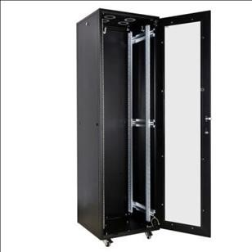

**42U-800 Rack specification**

|  |  |
| --- | --- |
| 42U-800 Rack specification | 42U-800 Rack specification |
| 42U-800 Rack specification | 42U-800 Rack specification |
| 42U-800 Rack specification | 42U-800 Rack specification |

**Patch Panel**

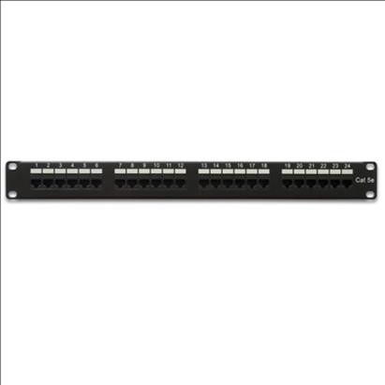

**Patch Panel specification**

|  |  |
| --- | --- |
| Brand | SMB |
| Model No | SMB-PP-CAT5E-012 |
| Category | CAT5e |
| Ports | 24 |

**Cable Management Panel**

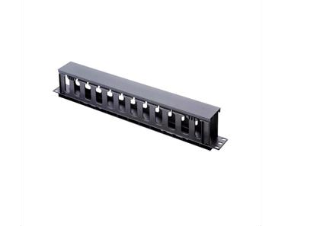

**Cable Management Panel specification**

|  |  |
| --- | --- |
| Mount Type | Rack Mount |
| Brand | Raising Electronics |
| Model | 95150-0118 |
| Rack Unit-Width | 19” |
| Rack Capacity | 1U |
| Rack Depth | 3.5 inches |
| Country Region of Manufacture | China |
| Type | 19” rack mount compatible |

**Sun Box**

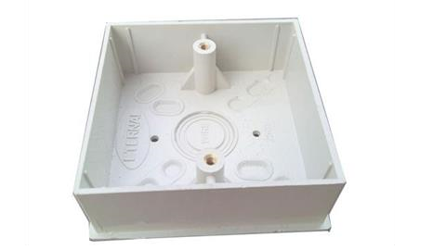

**Sun Box specification**

|  |  |
| --- | --- |
| Brand | Zhantai |
| Material | PVC |
| Size | 172*86*47 mm |
| Model | Zt-861B |
| Fire Retardant | Yes |

**Faceplate**

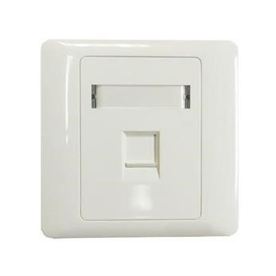

**Faceplate specification**

|  |  |
| --- | --- |
| Brand | OEM |
| Model | MB - 11 -08 |
| Category | RJ45, Cat5e, Cat6 |
| Port | 01 |
| Certification | ISO 9001 |

**Patch Code**

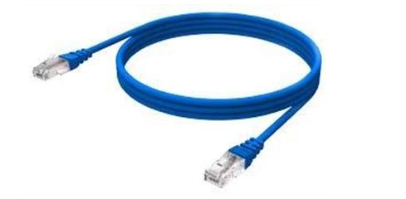

**Patch Code specification**

|  |  |
| --- | --- |
| Brand | OEM |
| Category | Cat5e, Cat6 |
| Shielding | UTP |
| Standard | ISO 11081 |
| Certification | ISO.UL |
| Conductor Material | BC, CCA |

**Keystone RJ45**

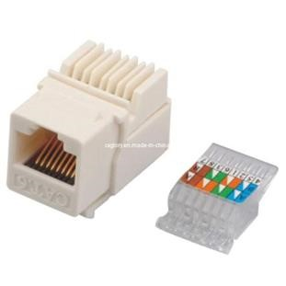

**Keystone RJ45 specification**

|  |  |
| --- | --- |
| Brand | OEM |
| Model Number | XXD- KJ20151902 |
| Termination | 110-Krone-Dual type |
| Standard | ISO 9001 |
| Type | RJ45 |

**RJ45 connectors**

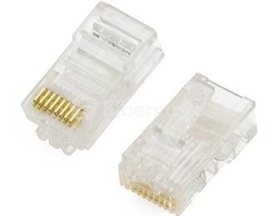

**RJ45 Connectors specification**

|  |  |
| --- | --- |
| Brand | OEM |
| Application | Network Table |
| Model Number | P88 |

**Boot Cover**

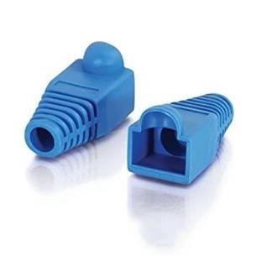

**Boot Cover specification**

|  |  |
| --- | --- |
| Boot Type | Snaggles |
| Color | Blue |
| Material | Environment friendly plastic |
| Compliant | CAT5e, UTP, CAT5e FTP |

**Trunking**

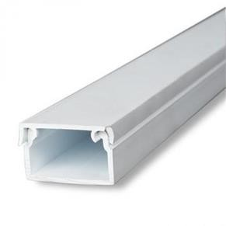

**Trunking specification**

|  |  |
| --- | --- |
| Brand | Orange Electricles |
| Color | White |
| Material | Steel |

## 2.7 Physical Topology

A physical topology is how device are actually interconnected with wires and cables. In physical topology there is some device.

* Switch
* Router
* Network Cable

## 2.7.1 Switch

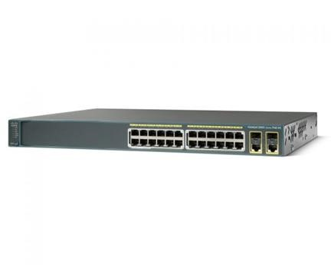

A network switch (also called switching hub, bridging hub, officially MAC bridge) is a computer networking device that connects devices together on a computer network by using packet switching to receive, process, and forward data to the destination device. A network switch is a multiport network bridge that uses hardware addresses to process and forward data at the data link layer (layer 2) of the OSI model. Some switches can also process data at the network layer (layer 3) by additionally incorporating routing functionality. Such switches are commonly known as layer-3 switches or multilayer switches. Switches for Ethernet are the most common form of network switch. The first Ethernet switch was introduced by Kalpana in 1990. Switches also exist for other types of networks including Fiber Channel, Asynchronous Transfer Mode, and InfiniBand.

## 2.7.2 Router



A router is a networking device that forwards data packets between computer networks. Routers perform the traffic directing functions on the Internet. A data packet is typically forwarded from one router to another router through the networks that constitute an internetwork until it reaches its destination node.

A router is connected to two or more data lines from different networks. When a data packet comes in on one of the lines, the router reads the network address information in the packet to determine the ultimate destination. Then, using information in its routing table or routing policy, it directs the packet to the next network on its journey.

The most familiar type of routers are home and small office routers that simply forward IP packets between the home computers and the Internet. An example of a router would be the owner's cable or DSL router, which connects to the Internet through an Internet service provider (ISP). More sophisticated routers, such as enterprise routers, connect large business or ISP networks up to the powerful core routers that forward data at high speed along the optical fiber lines of the Internet backbone. Though routers are typically dedicated hardware devices, software-based routers also exist.

## 2.7.3 Network Cable

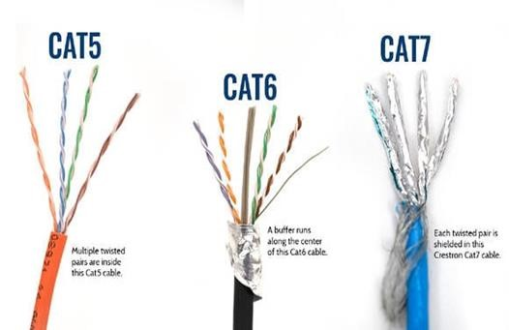

Networking cables are networking hardware used to connect one network device to other network devices or to connect two or more computers to share printers, scanners etc. Different types of network cables, such as coaxial cable, optical fiber cable, and twisted pair cables, are used depending on the network's physical layer, topology, and size. The devices can be separated by a few meters (e.g. via Ethernet) or nearly unlimited distances (e.g. via the interconnections of the Internet). There are several technologies used for network connections. Patch cables are used for short distances in offices and wiring closets. Electrical connections using twisted pair or coaxial cable are used within a building. Optical fiber cable is used for long distances or for applications requiring high bandwidth or electrical isolation. Many installations use structured cabling practices to improve reliability and maintainability. In some home and industrial applications power lines are used as network cabling.

## 2.8 Logical Topology

A logical topology is how devices appear connected to the user. In logically we have in this project

* IP Address
* DHCP
* Routing Protocol

## 2.8.1 Ip Address

An Internet Protocol address (IP address) is a numerical label assigned to each device connected to a computer network that uses the Internet Protocol for communication. An IP address serves two principal functions: host or network interface identification and location addressing. Internet Protocol version 4 (IPv4) defines an IP address as a 32-bit number. However, because of the growth of the Internet and the depletion of available IPv4 addresses, a new version of IP (IPv6), using 128 bits for the IP address, was developed in 1995, and standardized as RFC 2460 in 1998. IPv6 deployment has been ongoing since the mid2000s. IP addresses are usually written and displayed in human-readable notations, such as 172.16.254.1 in IPv4, and 2001:db8:0:1234:0:567:8:1 in IPv6. The size of the routing prefix of the address is designated in CIDR notation by suffixing the address with the number of significant bits, e.g., 192.168.1.15/24, which is equivalent to the historically used subnet mask 255.255.255.0.

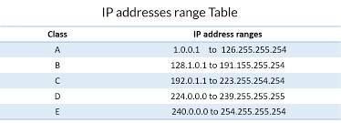

## 2.8.2 DHCP

The Dynamic Host Configuration Protocol (DHCP) is a network management protocol used on TCP/IP networks whereby a DHCP server dynamically assigns an IP address and other network configuration parameters to each device on a network so they can communicate with other IP networks. A DHCP server enables computers to request IP addresses and networking parameters automatically from the Internet service provider (ISP), reducing the need for a network administrator or a user to manually assign IP addresses to all network devices. In the absence of a DHCP server, a computer or other device on the network needs to be manually assigned an IP address.

## 2.8.3 Routing Protocol

A routing protocol specifies how routers communicate with each other, distributing information that enables them to select routes between any two nodes on a computer network. Routing protocols, according to the OSI routing framework, are layer management protocols for the network layer, regardless of their transport mechanism:

* IS-IS runs on the data link layer (Layer 2)
* Open Shortest Path First (OSPF) is encapsulated in IP, but runs only on the IPv4 subnet, while the IPv6 version runs on the link using only link-local addressing.
* IGRP, and EIGRP are directly encapsulated in IP. EIGRP uses its own reliable transmission mechanism, while IGRP assumed an unreliable transport.
* Routing Information Protocol (RIP) runs over the User Datagram Protocol (UDP).
* Version 1 operates in broadcast mode, while version 2 uses multicast addressing.
* BGP runs over the Transmission Control Protocol (TCP).

## 2.9 Quotation of the Network

|  |  |  |  |  |
| --- | --- | --- | --- | --- |
| **Name** | **Brand** | **Quantity** | **Price per Unit (LKR)** | **Price (LKR)** |
| Router Cisco 1841 | Cisco | 3 | Rs.86,559.00 | Rs.259,677.00 |
| Switch Cisco 2950 - 24 | Cisco | 2 | Rs.55,309.00 | Rs.110,618.00 |
| Hub Cisco Hub-PT | Cisco | 1 | Rs.10,000.00 | Rs.10,000.00 |
| Connectors RJ45 |  | 60 | Rs.70.00 | Rs.4,200.00 |
| Network Casing | Polycrome | 1000ft | Rs.56000.00 | Rs.56,000.00 |
| Wall plug/anchor Size 10 |  | 50 | Rs.2.00 | Rs.100.00 |
| Printers | PIXMA G2020 | 3 | Rs.41000.00 | Rs.123,000.00 |
| Network cable |  | 300m | Rs.130.00 | Rs.39,000.00 |
| TOTAL | | | | Rs.602,595.00 |

## 2.10 System Requirement

To develop the project, we have to get some system requirements to develop this project and here below we mentioned the minimum requirements to get access of

CISCO PACKET TRACRE 8.2

* Microsoft Windows 8.1, 10, 11 (64bit), Ubuntu 20.04 LTS (64bit) or macOS

10.14 or newer.

* Intl/amd64(x86-64) CPU.
* 4GB of free RAM.
* GB of free disk space.

## 2.11 Operational Requirement

The minimum requirement of the client pc is,

* CPU - Intel i3
* OS - Windows 7, Windows 8, Windows 10, windows 11
* RAM – 4 GB
* Storage - 500 GB

## 2.12 Software Requirement

To achieve this project, we need some system requirements to access packet tracer and that software are going to use packet tracer 8.2 also, it takes is 300mb to 350 mb in our local disk C to access this project. Packet Tracer is a similar that simulate router, switch and other networking equipment. Cisco devices are expensive. Packet Tracer cuts cost by simulating all necessary equipment. Simulation based learning environment helps students in getting hand on practice on Cisco devices. Packet Tracer is developed by Cisco system and it is freely available to networking academy instructors, students, administrators

## 2.13 Tools Required for the Network

**crimping tool:** used for the process of affixing the RJ-45 connectors to the end a cable

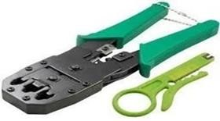

**screw driver:** for fixing the trunks.

**Hacksaw blade:** for cutting the trunks.



**Side cutter:** For cutting cables



**Electric drilling machine:** For drilling



**Punching tool:** To terminate Cables hole of screws.

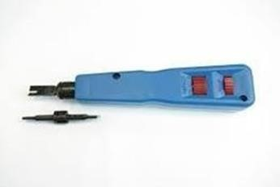

# **CHAPTER 03**

## PACKET TRACER DESIGN

## 3.1 Packet Tracer Designing Diagram

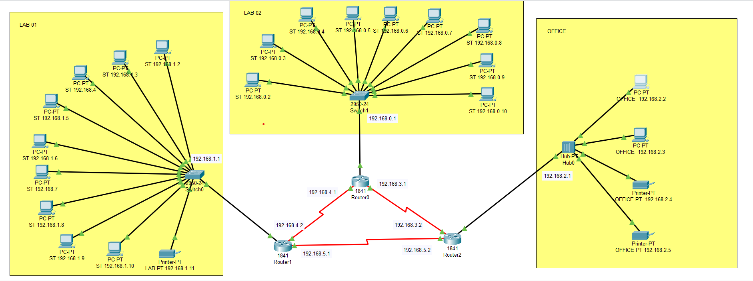

## 3.2 Network Addresses & IP Addresses

## 3.2.1 Switch 0 PC’s IP Address

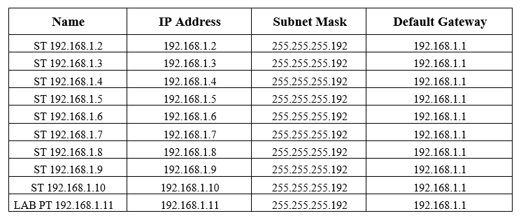

## 3.2.2 Switch 1 PC’s IP Addresses

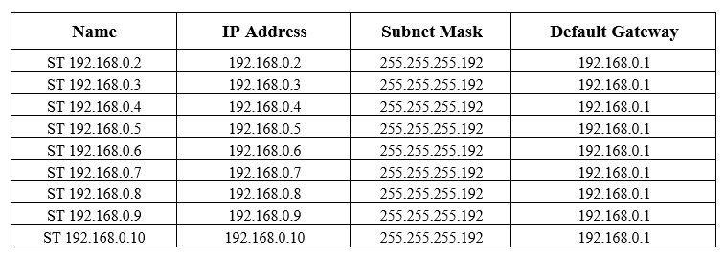

## 3.3.3 Hub to Office PC’s IP Address

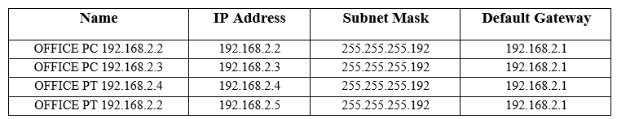

## Router 0 Configuration

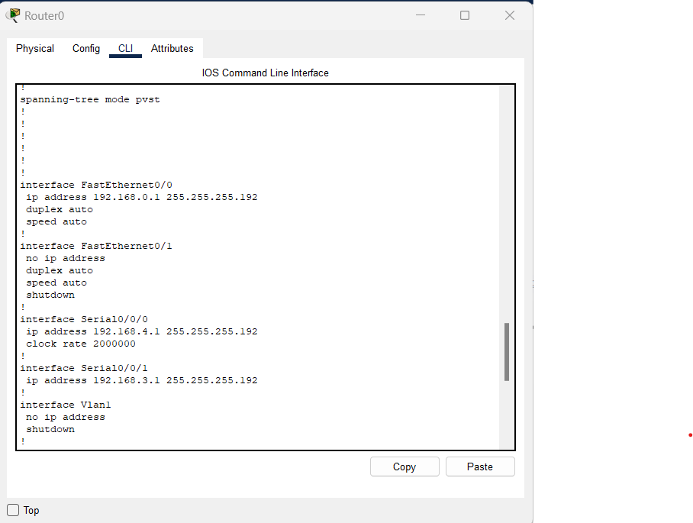

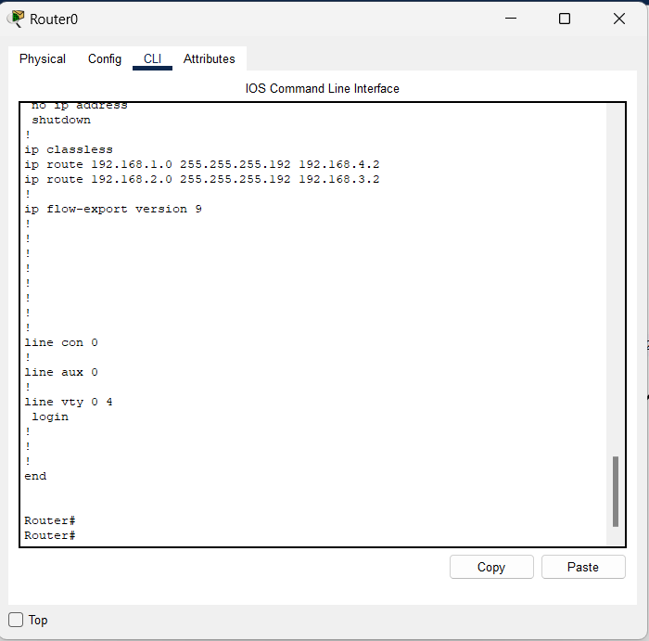

## Router 0 SHOW IP INTERFACE BRIEF

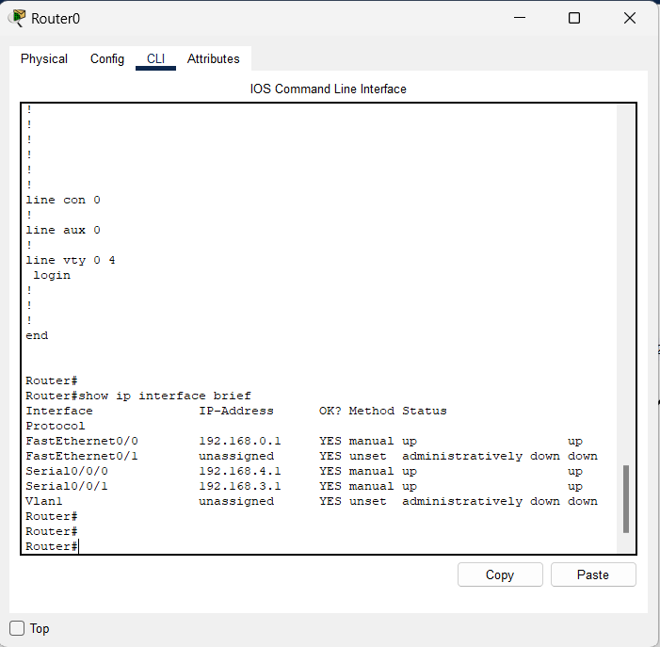

## Router 1 Configuration

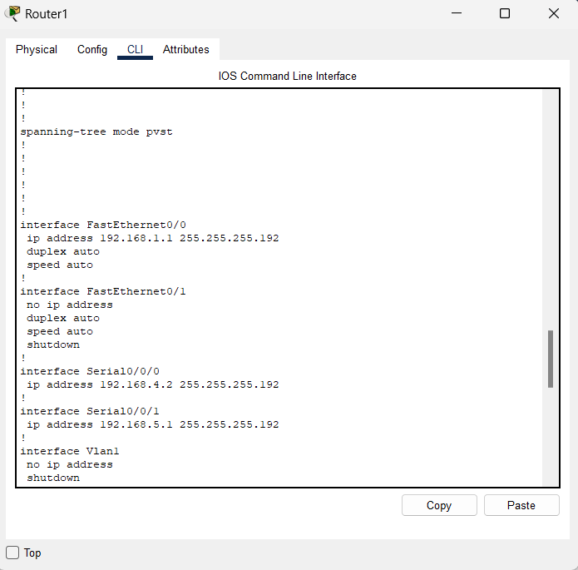

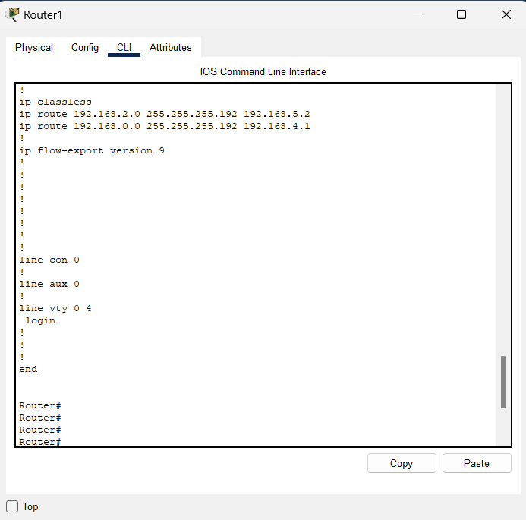

## Router 1 SHOW IP INTERFACE BRIEF

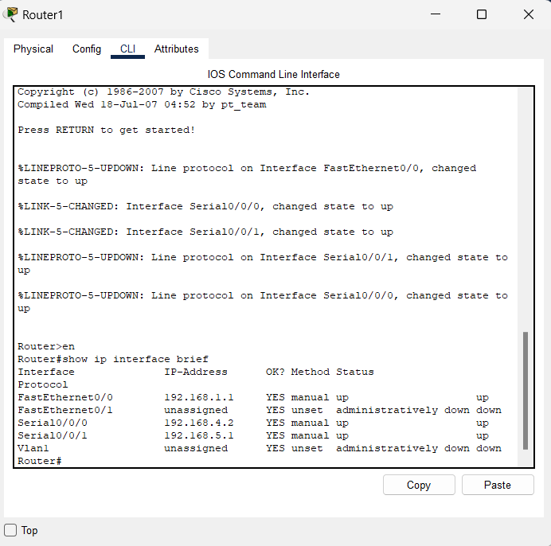

## Router 2 Configuration

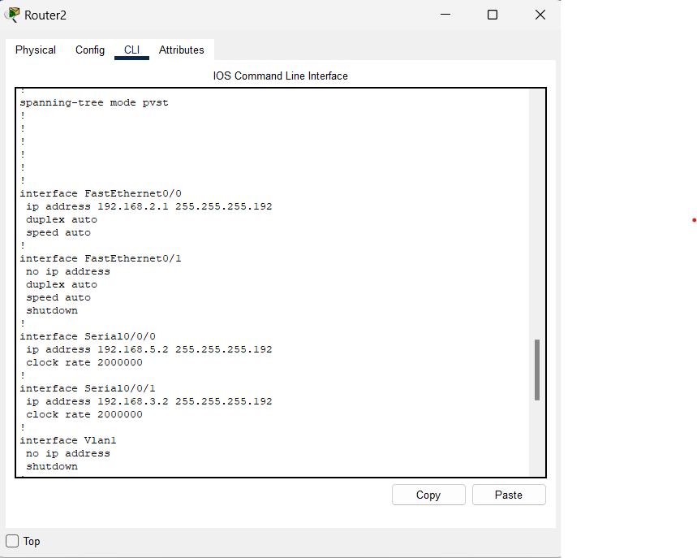

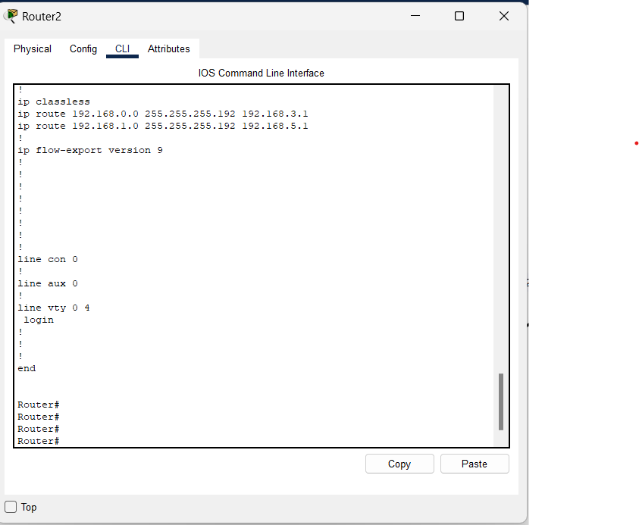

## Router 2 SHOW IP INTERFACE BRIEF

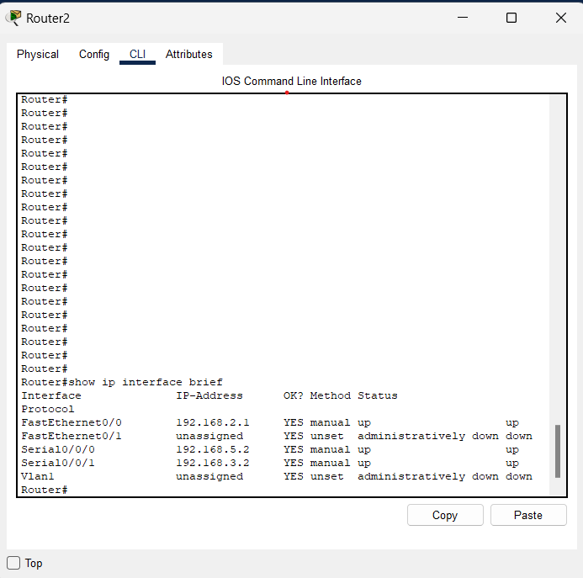

## Printer working

* **L****ab 1 printer**

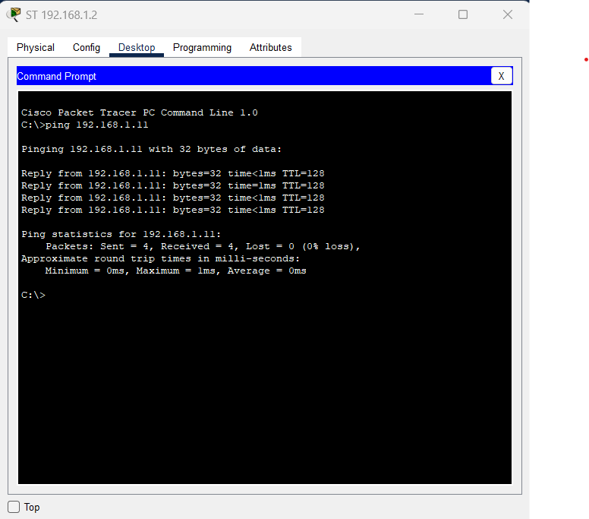

* **Office Printer**

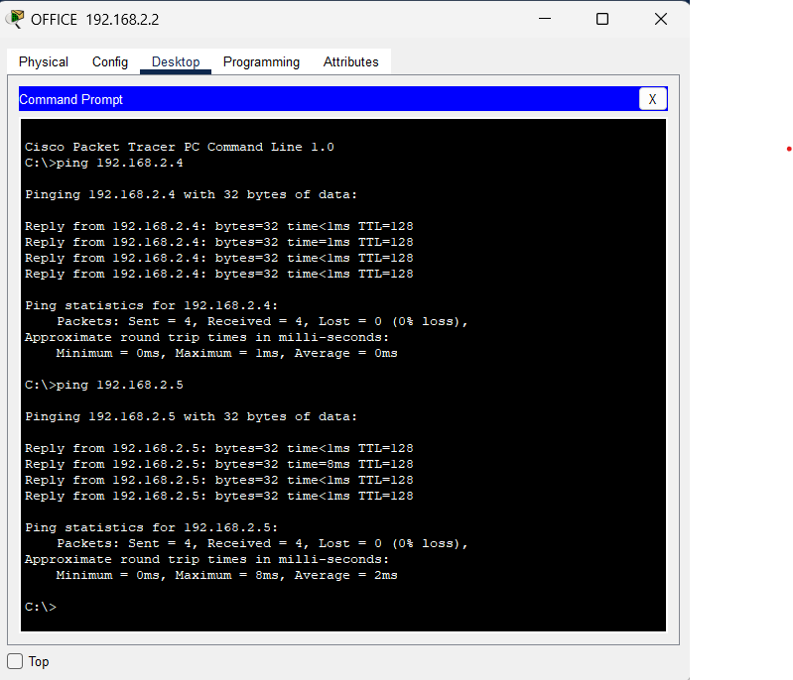

**Ping – Office to Lab 1**

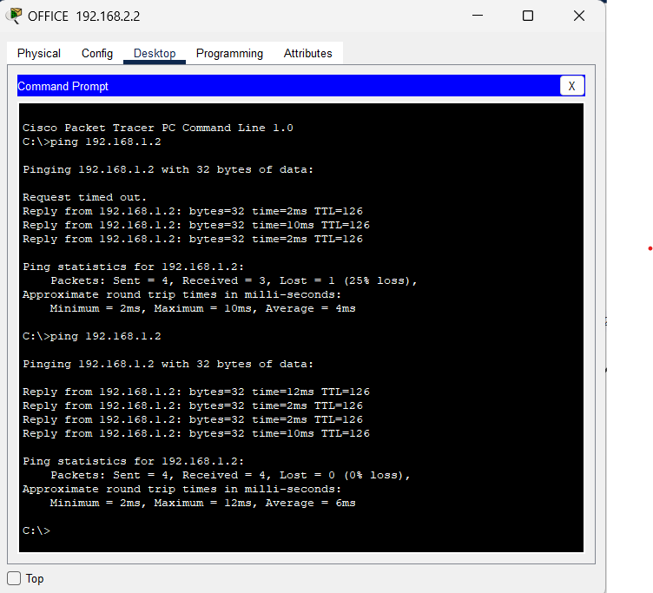

**Ping – Office to Lab 2**

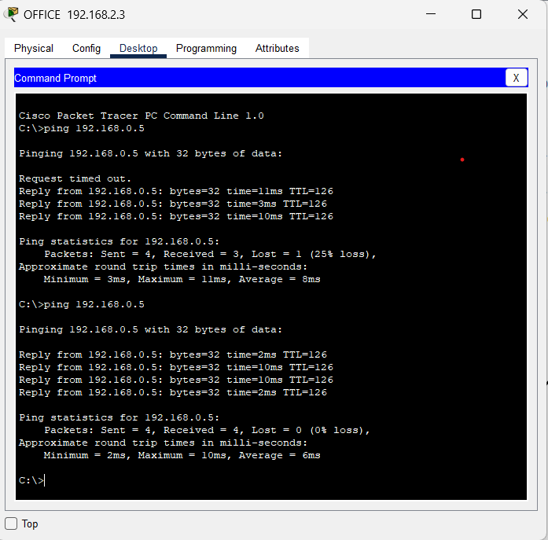

## REFERENCES

* **<https://app.diagrams.net/>**
* **<https://www.cisco.com/site/sg/en/products/networking/sdwan-routers/index.html>**
* [**https://www.youtube.com/watch?v=X7f5sgfAsAo**](https://www.youtube.com/watch?v=X7f5sgfAsAo)
* [**https://www.netacad.com/courses/packet-tracer**](https://www.netacad.com/courses/packet-tracer)
* [**https://www.cisco.com/c/en/us/td/docs/security/asa/asa72/configuration/guide/conf_gd/ip.html**](https://www.cisco.com/c/en/us/td/docs/security/asa/asa72/configuration/guide/conf_gd/ip.html)